|  |  |
| --- | --- |
| Course Name | ITD 3243 – Server Side Programming |
| Instructor | Mark L. Pranger |
| Student Name | Sharyl Hammer |
| Due date | February 8, 2018 |
| Grade | 100 |
| Grading Comments | <instructor comments here> |

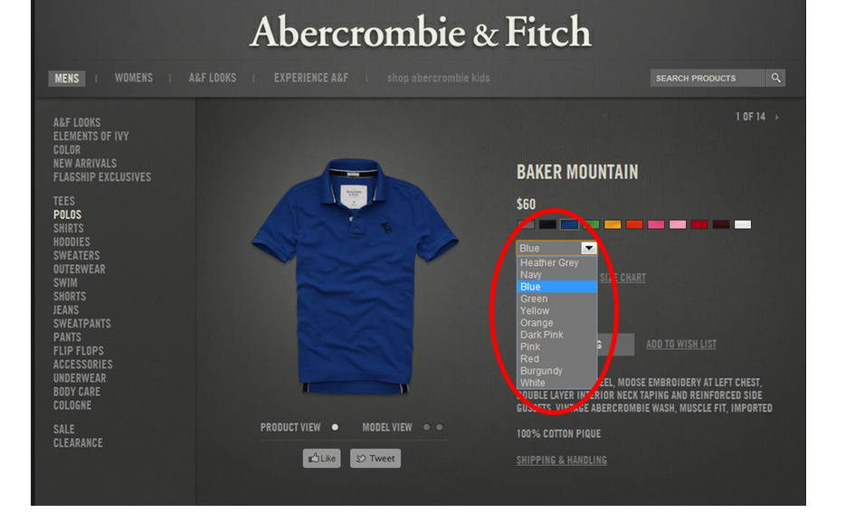

This is an example of a drop- down list. The HTML uses the select tag. The select tag has an attribute value which would be color in this example. The option values would be the color values in the HTML. The name and value pair selected which would be color for the name and the value would be blue. The PHP code accesses the selected name and value with the filter_input function using the INPUT_POST with the name value being color. The code would be $color = filter_input(IINPUT_POST, ‘color’);

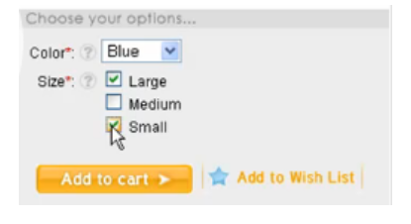

This is an example of check box element. The HTML input type is a checkbox. The input name is the values of the check box. The default value for a checkbox is checked. The checkbox selection allows more than one selection. The PHP code uses a function isset() which is used with the $_POST array for each value to determine if the value was selected. If the value was selected then the isset function will return value of true. The values that would return true would be Large and Small in this example.

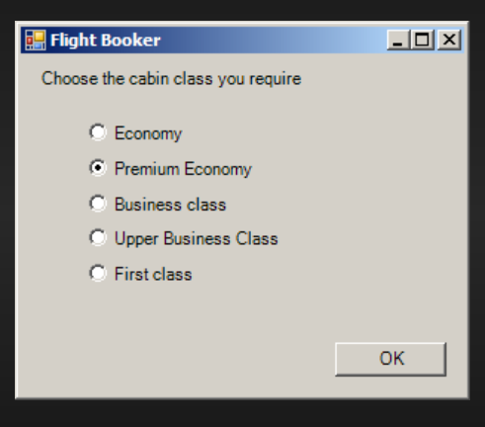

This is an example of radio box element. The user has selected Premium Economy for the cabin class. The HTML code uses an input type tag of radio and the name attribute would be cabin_class. The name of cabin_class would be used for all input tags. The value attribute is for the first radio button displayed would be Economy. The radio button selection allows only one value to be selected from the options. The name and value pair will be passed to the $_POST array. The name for the selected value would be cabin_class and the value would be Premium Economy. The PHP code accesses the value of the radio button selected from the $_POST array using the filter_input function

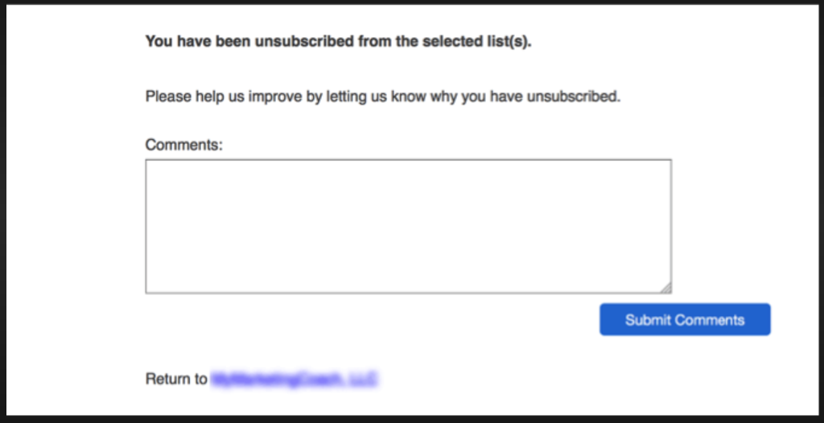

Example of a Text Area. This text area box allows a user to type in comments in the text area. The HTML <textarea > tag would have the attributes of the name which would be comment. The number of rows and columns are given values. The text that is typed between the parameters of the row and columns value is passed to the comment value. The name and value pair will be submitted in $_POST array which the name would be the comment and the value is the text typed in the text area box. The PHP code gets the comment value using the filter_input() with the INPUT_POST with the name value ‘comment’

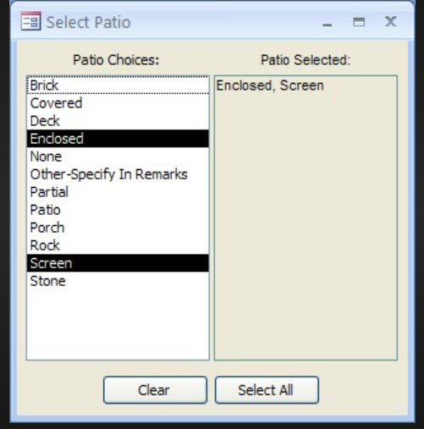

Example of a List Box that allows Multiple Selections. The list box values selected for a Patio are Enclosed and Screen. The select tag in the HTML would include the attribute value of multiple which allows the user to select more than one value from the list box. The size of the list box would be 12 which indicates that there are 12 patio choices to select from. The values that are selected will be placed in a $_POST array. The name and value pair will of patio selection will be passed in the $_POST array. The name would be patio and the values would be Enclosed and Screen. The PHP code accesses the values that have been selected in the $_POST array using the filter_input () with the INPUT_POST, ‘patio’, the FILTER_REQUIRE_ARRAY must be used otherwise the filter_input function won’t work correctly.

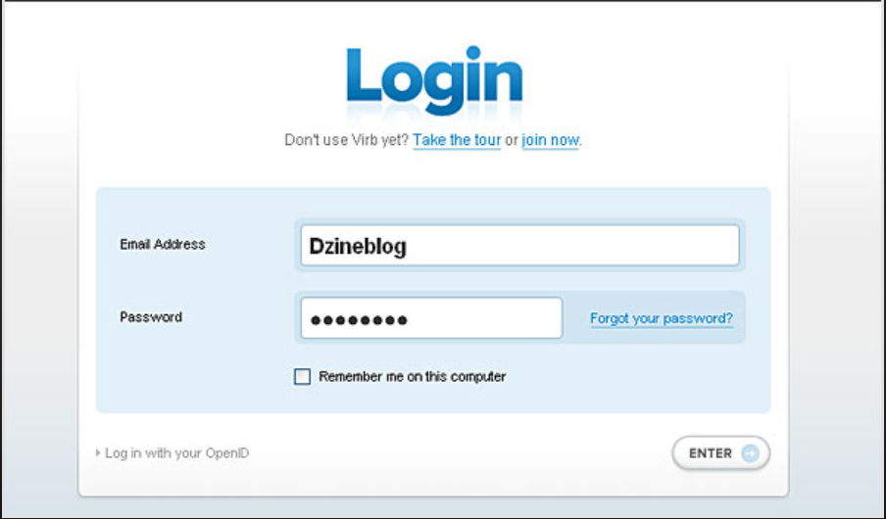

Example of an email address and password fields. The text box field accepts the value from the email address field. The value of the email address which is Dzineblog is passed to the $_POST array. The post method would be used since there is a password. The password should not be displayed and the $_POST method will not display the password. The password value will be passed in the $_POST array. The $_POST array is passed in the browser to the PHP code. The PHP code will use the filter()input function for the POST method to access the email address value and the password value.